SOMERSAULT

January 2017

Vol 40, No 1

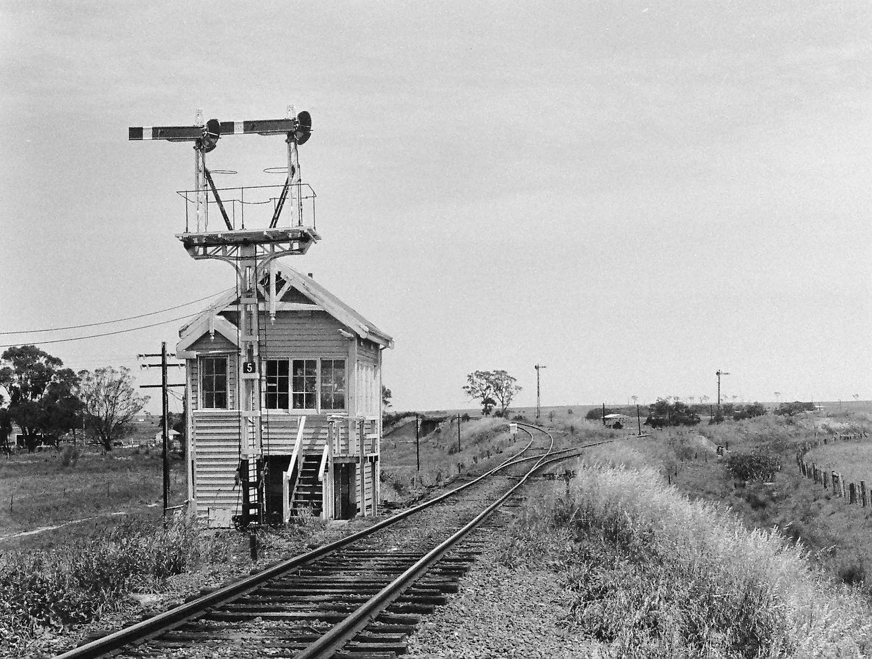Signalling Record Society of Victoria

# Society Contact Information

(Front cover). Victoria was not blessed with many signal boxes that were remote from passenger stations. Stratford Junction, shown here, is one. The line from Maffra to Stratford was opened on 8 November 1887 whilst the line from Sale to Stratford Junction and beyond Stratford to Bairnsdale was opened on 8 May 1888. Stratford is on the northern side of the Avon River, but the two lines met on the southern bank of that river, hence the necessity for Stratford Junction. The signal box was provided with the opening of the line to Sale, and for the whole of its life retained its nine working levers and five spaces in the 14 lever rocker frame. This view is taken from the Stratford side looking in the Up direction. The line heading to the left is towards Sale and the line to Maffra heads off to the right. The safeworking was Staff & Ticket from opening, but in March 1915, large pattern electric staff replaced the staff & ticket in all three directions. On 8 September 1986, the signal box was abolished. The ES section becoming Sale to Stratford with an intermediate instrument at Stratford Junction. The junction points were interlocked and staff & ticket was provided to Maffra. This situation lasted for only two years when the Maffra 'siding' - as it had become known - became part of the Sale - Stratford section and the main line staff was also used to go to Maffra with the points being locked reverse until the train returned with the staff. All this, however, ceased on 9 March 1995 when the Maffra line was closed and Stratford Junction ceased to be. Photo David Langley

Published by the Signalling Record Society Victoria Inc (A0024029F)

EDITOR: Andrew Waugh, 28 Amelia St McKinnon, VIC, 3204  
Phone (03) 9578 2867 (AH), (03) 9348 5724 (BH), email andrew.waugh@gmail.com

PRESIDENT: David Langley, P.O. Box 8, Avenel, VIC, 3664, Phone (03) 5796 2337

SECRETARY and MEMBERSHIP OFFICER: Glenn Cumming,  
Unit 1/4-6 Keogh St, Burwood, VIC 3125. Phone (03) 9808 0649 (AH)

NSW CONTACT: Bob Taaffe, 63 Hillcrest Rd, Tolmans Hill, TAS, 7007, Phone: (03) 6223 1626

QUEENSLAND CONTACT: Phil Barker  
PO Box 326, Samford, QLD, 4520, Phone: (07) 3289 7177, email: signal-1@bigpond.com

Unless articles use copyrighted information, articles may be reprinted without prior permission but acknowledgment is required. Opinions expressed in articles appearing in SOMERSAULT or supplements are not necessarily those of the S.R.S.V. (Inc.)

# Minutes of Meeting held Friday 18 November 2016, At the Box Hill Miniature Steam Railway Society, Elgar Road, Box Hill North, Victoria

Present: – Ken Ashman, Noel Bamford, Wilfrid Brook, Glenn Cumming, John Dennis, Mike Drew, Graeme Dunn, Michael Formaini, Ray Gomerski, Chris Gordon, Andrew Gostling, Chris Guy, Graeme Henderson, Bill Johnston, David Jones, Chris King, Keith Lambert, David Langley, Neil Lewis, Andrew McLean, Philip Miller, Alex Ratcliffe, Laurie Savage, Brian Sherry, Rod Smith, David Stosser, Bob Taaffe, Rob Weiss, Andrew Wheatland and Ray Williams.

Apologies: – Steven Dunne, Judy Gordon, Steve Malpass, Michael Menzies, Peter Silva, Colin Rutledge and Andrew Waugh.

Visitor: – Bill Hanks and Kevin Taig.

The President, Mr. David Langley, took the chair & opened the meeting at 20:05 hours.

Mr. Bill Hanks, President of the Box Hill Miniature Steam Railway Society welcomed everybody to the BHMSRS club rooms.

Minutes of the September 2016 Meeting: – Accepted as published. Chris Gordon / David Stosser. Carried.

Business Arising: – Nil.

Correspondence: – Letter to David Ward at Metro Trains Melbourne thanking him for granting permission for the signal box tour.

Letter to Trevor Wyatt at Metro Trains thanking him for his assistance with the suburban signal box tour.

Letter to Keith Lambert thanking him for his assistance with the suburban signal box tour.

Letter to Surrey Hills Neighbourhood Centre with dates for meetings in 2017.

Letter and cheque received from AREA providing funding for a project to establish a website for SRSV and to commence scanning of documents in SRSV collection.

Letter to AREA acknowledging receipt of cheque and thanking AREA for providing the funding.

Philip Miller / Michael Formaini. Carried.

Reports: – Tours. A report on the successful signal box tour in September 2016 was provided. Suggestions are invited for future tours.

General Business: – Keith Lambert provided details about various works in the Metropolitan District. A summary of the discussion follows: –

* Sunshine Signal Box was abolished on Sunday 23 October 2016. Control has been transferred to Metrol.
* Ringwood Signal Box will be converted from a unit lever control panel to screen based computer equipment next weekend.
* Grade separation works at Bayswater will be completed by Monday 12 December 2016.
* At Lilydale, pedestrian gates will be provided at the pedestrian crossing at the Down end of the platform.
* A proposal for alterations to the junction of the Cranbourne Line at the point of divergence was described.

Keith Lambert described arrangements for absolute occupations in the Flinders Street – Richmond area. Up trains from the Caulfield Lines will terminate at Richmond. The trains will use the tracks in the underground loop tunnel portals to reverse to form Down trains for the Caulfield Lines.

Rod Smith asked when the Burnley – Camberwell re-signalling works will be completed. The answer given is that these signalling works are planned for completion in Easter 2017.

Michael Formaini congratulated Andrew Waugh on the article on Communications Based Train Control (CBTC) published in the November 2016 issue of “Somersault”.

Syllabus Item: - The President introduced members Ken Ashman and Bob Taaffe to present the Syllabus Item.

Ken and Bob discussed Absolute Permissive Block (APB) systems in Australia and New Zealand.

Bob commenced the discussion by reviewing the various APB systems introduced across Australia and New Zealand in the 1920’s based on his research to date. Similarities and differences in details like signal spacing and arrangements at crossing loops were compared between each system.

Ken followed with a discussion on the development of APB by Sedgwick N. Wight of the General Railway Signal Company followed by a detailed explanation of the how the system worked.

Ken then provided details of how the APB system had been modified in New Zealand along with an explanation of how the system operates in New Zealand today.

A number of questions from those present were answered by Ken and Bob.

At the completion of the Syllabus Item, the President thanked Ken and Bob for the presentation & this was followed by acclamation from those present.

At the completion of the meeting, the President thanked Bill Hanks and the Box Hill Miniature Steam Railway Society for hosting tonight’s meeting and for the tour of the signal box.

Meeting closed at 22:46 hours.

The next meeting will be on Friday 17 February, 2017 at a location to be advised, commencing at 20:00 hours (8.00pm).

# Signalling Alterations

The following alterations were published in WN 39/16 to WN 46/16, and ETRB A circulars. The alterations have been edited to conserve space. Dates in parenthesis are the dates of publication, which may not be the date of the alterations.

06.09.2016 Mildura (TON 168/16, WN 40)

On 6.9., the points to the Mildura Cement Siding (606.636 km) were booked out of use as the siding is no longer in use.

26.09.2016 Murrumbeena (SW 249/16, WN 33)

On Monday, 26.9., the Up platform was shortened by 7.5 metres at the Down end. The length of the platform is now 153 metres. Amend Diagram 5/12 (Carnegie – Huntingdale).

(27.09.2016) North Geelong C (SW 106/16, WN 39)

The signaller at North Geelong C can issue Track Warrants on the following running lines:

* Dual Gauge main line between Signals 14 and CGL40
* Corio Independent Goods Line between signals CGL40, CGL30, and CGL32
* Geelong Grain Loop

27.09.2016 Blackburn – Nunawading (SW 313/16, WN 40)

From Tuesday, 27.9., the King/Oliver St pedestrian crossing will be closed to allow construction work.

28.09.2016 Newport (SW 291/16, WN 39)

Between Monday, 26.9., and Wednesday, 28.9., Points 607, 608U, and 610U were provided with M23A dual control point machines. The selector lever of these point machines will be secured by a signal maintenance padlock. Amend Diagram 13/15 (Newport).

30.09.2016 Werribee (SW 282/16, WN 40)

On Friday, 30.9., the V/Line signal overview VDU was replaced due to updated control systems.

(04.10.2016) North Geelong (SW 111/16, WN 40)

Operating Procedure 60 (North Geelong Yard) was re-issued. The change was that the Master Key Securing Box at North Geelong Yard has been removed. SW 17/15 was cancelled.

(04.10.2016) Waurn Ponds (SW 113/16, WN 40)

Operating Procedure 64 (Waurn Ponds) was re-issued. The Master Key for Waurn Ponds is held at North Geelong C. SW 17/15 is cancelled.

(04.10.2016) Ballarat (SW 110/16, WN 40)

Operating Procedure 69 (Ballarat Signalling and Train Orders) was re-issued. The changes reflected the relocation of control to Centrol, permission to issue Ballarat East – Batesford Train Orders at Maryborough; and that Master Keys are no longer held at Ballarat. SW 149/13 was cancelled.

(04.10.2016) Ballarat – Ararat (SW 110/16, WN 40)

Operating Procedure 70 (Ballarat – Ararat Train Staff and Ticket Working) was re-issued. The change was that the Driver is to confirm with the Train Controller that the Driver is in possession of the Train Staff or Ticket prior to being signalled from Ballarat. SW 52/16 was cancelled.

04.10.2016 Albion – Sydenham (SW 315/16, WN 40)

On Tuesday, 4.10., the line between Albion and Sydenham was booked out of service to permit final construction of the grade separation works at Main Road, St Albans, and Furlong Road, Ginifer.

The existing station buildings and platforms were abolished at St Albans and Ginifer. The Main Road and Furlong Road level crossings were abolished, together with the boom barriers and pedestrian gates. The Ruth Street and Mulhall Drive pedestrian crossings were abolished together with the pedestrian gates.

Automatic signals M573, M578, M602, M603, M619, M622, M637 (and co-acting signal), M650 (and co-acting signal), M655, M675, M678, and M704 were abolished.

Amend Diagrams 21/15 (Albion – St Albans) and 1/15 (Keilor Plains – Sydenham)

(11.10.2016) Road/rail operations (SW 118/16, WN 41)

Operating Procedures 131 (Road Rail Operations) was reissued. Changes are: additional procedures for vehicles operating in convoy; and a procedure for following the Rail Flaw Detector Car. SW 72/16 is cancelled.

(11.10.2016) Burnley (SWP 8/16, WN 41)

Burnley Group Operating Procedure 1 (East Richmond – Emergency Operation of Electro-hydraulic Points) has been cancelled due to the removal of the pump handle (SW 141/16).

12.10.2016 Middle Brighton (SW 293/16, WN 39)

On Wednesday, 12.10., magnetically latched emergency exit gates were provided at Church Street.

14.10.2016 Blackburn – Nunawading (SW 326/16, WN 41)

On Friday, 14.10., the Cottage St pedestrian crossing will be reopened. The automatic pedestrian gates were restored to use.

14.10.2016 Bayswater (SW 324/16, WN 41)

On Friday, 14.10., circuit alterations were made at Mountain Highway and Scoresby Road. The Down approach to Scoresby Road and the Up approach to Mountain Highway were altered to always be in Express mode. Alterations were made in the controls of BAY306 and BAY309 to support this alteration.

When the Bayswater control panel is switched in, the Signaller at Ringwood must ensure that the correct stopping/express selection is made as per the working timetable. This is to ensure the correct operation of the flashing lights at Heathmont (Up trains) and Ferntree Gully (Down trains).

16.10.2016 Sunshine (SW 317/16, WN 41)

Over the night of Sunday, 16.10 and Monday, 17.10., testing of the TCMS functionality for Sunshine will be undertaken from the disaster recovery site. This will involve disconnecting the Westcad system at Sunshine, loading a new software build for the TCMS at the disaster recovery site, connecting the TCMS software to the Sunshine IFPM and Westlock, and testing the control and indications. On completion of the tests, control will be returned to Sunshine signal box.

17.10.2016 Craigieburn (SW 309/16 & 325/16, SWP 7/16, WN 40 & 41)

Between 0030 hours Saturday, 15.10., and 0400 hours Monday, 17.10., the Craigieburn CBI was upgraded to a Westrace Mark 2 system.

Signals CGB510, CGB514, CBG537, and CGB539 were equipped with TPWS(TSS). These signals are fitted with a plate lettered ‘TPWS’.

The train stabling siding compound gates Nos 408 and 420 were commissioned for Automatic operation and were interlocked with the signals.

Northern Group Operating Procedure 19 was re-issued. A new clause j was added (Craigieburn Train Stabling Siding Compound Gates).

Diagram 25/16 (Craigieburn) replaced 59/11.

(18.10.2016) Birchip (SW 119/16, WN 42)

The notice board at the Up end of Birchip Loop was altered to apply for all Up trains. The speed restriction of 40 km/h will only apply to Wycheproof Rd.

18.10.2016 Use of Tilting Signal Mast – Dwarf signal (SWP 10/16, WN 46)

Commencing Monday, 18.10., Metro Trains General Operating Procedure 10 (Use of Tilting Signal Mast – Dwarf signal” came into effect.

Dwarf signals located on main lines must not be lowered during the period of train operations. Where a Dwarf signal is located in sidings, trains must not be signalled to or from the siding to which the Dwarf signal applies.

Before lowering a Dwarf Tilting Mast, the Maintenance Technician will obtain the permission of the controlling Signaller. Before granting permission, the controlling Signaller must obtain permission of the Train Controller, Metrol. The Maintenance Technician must place a hand signaller at the affected signal with a red hand signal to mark the location of the lowered signal mast. If a train is at, or moved up to, the signal, the train is to be held at the signal until the maintenance work is completed.

18.10.2016 Ouyen (TON 177/16, WN 43)

On Tuesday, 18.10., No 4 Track was booked out of use due to decayed point timbers. Points are secured to prevent any movement entering No 4 Track.

18.10.2016 Kilmore East (SW 121/16 & 122/16, WN 42)

On Tuesday, 18.10., gate locks were provided on the emergency exit gates at the Station access pedestrian crossing at 63.353 km.

21.10.2016 Bendigo (SW 116/16, WN 40)

Between Tuesday, 4.10., and Friday, 21.10., the rodded connections to the derails and crowders worked from the point machines at Points 5, 13, and 15 were removed. Derail and Crowders 5 and 15 will be provided with dual control point machine. Derail and Crowder 13 (exit of the Independent Track) was replaced by a catch point operated by a dual control point machine. Amend Diagram 104/12 (Bendigo).

23.10.2016 Sunshine (SW 318/16, WN 42)

Between 2100 hours on Sunday, 23.10., and 0400 hours on Monday, 24.10., Sunshine signal box was closed. Control of Sunshine and Albion Junction was transferred to the Western Panel, Metrol. There was no change to signalling arrangements, and the instructions relating to long train release (SW 268/15) will continue to apply.

The existing Westcad signal control system at Sunshine will be disconnected, but will remain on site. The new SUN IFPM will be connected to the SUN Westlock. The West Footscray and Sunshine JZA field stations in the Sunshine signal equipment room will be decommissioned, but will remain in situ.

The Sunbury panel at Craigieburn will be altered to provide a train number interface for transferring train numbers between the two systems. Craigieburn (Sunbury panel) will be provided with a TCMS fringe screen, and the existing Train Number Transmitter will become obsolete.

23.10.2016 Upper Ferntree Gully (SW 341/16, WN 43)

On Sunday, 23.10., a 5P keyswitch was attached to the panel to reset the Railmaster remote control system. The keyswitch must only be operated after the signaller has ensured all trains between Upper Ferntree Gully and Belgrave are stationary, and permission has been received from the Fault Officer at the Signal Fault Centre.

24.10.2016 Warrnambool (TON 178/16, WN 43)

On Monday, 24.10., the Turntable Rd (No 5 Road) was booked out of service due to construction work associated with No 3 Road.

24.20.2016 California Gully (TON 179/16, WN 43)

On Monday, 24.10., the siding was booked out of service due to damaged channel rodding at the Up and Down end points. The main line points are secured normal.

(25.10.2016) Melbourne Yard (SW 126/16, WN 43)

Effective forthwith, the North Canal Lead is not available for traffic.

Points MYD105 in the Reversing Loop was secured normal. Hollands Loop was baulked opposite Stop Board 4, and the Dual Gauge Lead was baulked opposite Stop Board 7 and Dwarf APD26.

(25.10.2016) Bendigo (SW 125/16, WN 43)

Diagram 34/16 (Bendigo) replaced 104/12. The main alteration is the alteration to roll-out protection described in SW 116/16.

26.10.2016 Caulfield – Murrumbeena (SW 340/16, WN 43)

On Monday, 26.10., (sic) the Cosy Gum Rd and Blackwood Street pedestrian crossings were closed. The control circuits were isolated and the gates were secured closed. Amend Diagram 5/12 (Carnegie – Huntingdale).

28.10.2016 Sunshine – Albion (WN 46)

On Friday, 28.10., Metro Trains Northern Group Operating Procedure 9 (Sunshine – Albion Failure of signals) was reissued. SWP 9/12 was cancelled.

31.10.2016 Albion – Sydenham (SW 315/16, WN 42)

On Monday, 31.10., the new grade separated lines between Albion and St Albans were brought into use.

The Up and Down lines were slewed to new alignments at Ginifer and St Albans. New stations with 164 metre Up and Down platforms were provided at Ginifer (15.968 km) and St Albans (17.835 km).

New over line bridges will be provided at Furlong Road (15.875 km) and Main Rd (17.914 km). Footbridges replaced the pedestrian crossings at Mulhall Drive (16.085 km) and Ruth St (18.503 km). New pedestrian footbridges were provided at the Up and Down ends of St Albans station. The footbridge at the Up end (17.745 km) is known as the ‘Station Precinct’ while that at the Down (18.138 km) is the “Inner Circus”.

New Automatic signals were provided: M658, M577, M605, M606, M628, M637, M659, M660, M688, and M722. All these signals are equipped with TPWS(TSS). M660 is also provided with TPWS(OSS).

Existing Automatics ALB433 and M539 were equipped with TPWS(TSS).

Diagrams 17/16 (Albion – St Albans) and 19/16 (Keilor Plains – Sydenham) replaced 21/15 and 1/15 respectively.

31.10.2016 Epsom Block Point (SW 124/16, 128/16, & 129/16, WN 43 & 44)

On Monday, 31.10., Epsom Block Point was provided at 169.955 km on the Down side of Howard Street. The Train Order Sections are now North Bendigo – Epsom BP – Hunter BP.

Block Point signs (white triangle with black text) were provided on both sides of the line at 169.955 km. Up and Down Location Boards were provided approximately 2.5 km in the rear of the block point signs. Location Clearance signs were provided on the rear of the Location Boards. Bi-direction electronic end of train detection was not provided.

Operating Procedure 108 (Epsom) was reissued to reflect the opening of Epsom Block Point and to contain additional instructions for the issue of Train Orders. SW 197/14 is cancelled. Operating Procedure 131 (Train Order Territory) was re-issued and SW 4/16 was cancelled.

Amend Diagrams 20/13 (North Bendigo Junction) and 114/14 (Epsom – Elmore).

02.11.2016 Bayswater (SW 348/16, WN 44)

On Wednesday evening, 2.11., Scoresby Road was abolished as a level crossing to allow the final grade separation work to commence. The crossing was closed to road and pedestrian traffic. The crossing will not be closed to rail traffic until Friday, 4.11.

05.11.2016 Glenhuntly (SW 327/16, WN 41)

On Saturday, 5.11., electromagnetic latched emergency exit gates were commissioned at Glenhuntly Road.

07.11.2016 Patterson (SW 364/16, WN 45)

Between Friday, 4.11., and Monday, 7.11., Up Automatics F535 and FM535 were converted to LED.

(08.11.2016) Melbourne Yard (SW 130/16, WN 45)

Effective forthwith, the following alterations have been implemented to exclude rail traffic from the North Canal Lead.

Points MYD105 in the Reversing Loop were secured normal. Hollands Loop was baulked opposite Stop Board 4. The broad gauge track leading to the Dual Gauge Lead was baulked 50 metres on the Up side of Stop Board 7 and Dwarf APD26.

Broad gauge movements are not permitted past Stop Board 7, however, the standard gauge movements are permitted to pass Stop Board 7 on the lead towards the baulks on the South Canal Lead.

SW 126/16 was cancelled.

09.11.2016 Caulfield Underground Loop (SW 353/16 & SW 362/16, WN 44 & 45)

On Wednesday, 9.11., Home 600 between Spencer St and Flagstaff was upgraded to LED. The lamp proving function for Home 600 was disabled.

09.11.2016 Rainbow (TON 130/16, WN 46)

On Wednesday, 9.11., the Down end mainline points (428.625 km) were booked out due to the point lever not being effectively secured.



10.11.2016 North Melbourne (SW 354/16 & 363/16, WN 44 & 45)

On Thursday, 10.11., the A and B arm signal lights on Home 515 (Main Suburban Ramp) were upgraded to LED. On Friday, 11.11., the low speed light and illuminated letter ‘A’ on Home 515 were upgraded to LED.

14.11.2016 Burnley (SW 312/16, WN 46)

In the evenings between Monday, 14.11., and Wednesday, 16.11., Up Glen Waverley line trains will terminate in Platform 1 at Burnley. Down Glen Waverley trains will originate in Platform 1 and run wrong line to Crossover 280 near Madden Grove, which is an unsignalled movement.

Hand signallers will be stationed at the Down end of No 1 Platform at Burnley and at Crossover 280. A competent employee will operate the test switch at Madden Grove for Down movements. The hand signaller on the platform will inform the Driver of the train that a second hand signaller is located at Crossover 280, and, at departure time, display a green hand signal as authority for the train to depart. The hand signaller must then inform the hand signaller at Crossover 280 that the train has departed. The train must not exceed 10 km/h until the train has cleared Madden Grove. The hand signaller at Crossover 280 must display a red hand signal to the approaching train and ensure that Crossover 280 are reverse and secured. When the Madden Grove boom barrier are horizontal, the hand signaller will display a green hand signal.

14.11.2016 Clayton (SW 369/16, WN 46)

On Monday, 14.11., Down Automatic D625 will be relocated 5 metres in the Up direction.

(15.11.2016) Blackburn – Nunawading (SW 375/16, WN 46)

The King St/Oliver Ave pedestrian crossing has been closed.

15.11.2016 Flinders St – Richmond Junction (SW 376/16, WN 46)

On Tuesday, 15.11., Up Automatic 267 (Burnley Through) will be converted to a TC2 LED signal.

16.11.2016 Camberwell – Failure of Signals (SWP 14/16, WN 47)

On Wednesday, 16.11., Burnley Group Operating Procedure 4 (Camberwell Failure of signals) was reissued. The main changes are: the signal box telephone lines are recorded; instructions are included for the manual operation of the HWMKII point machines; and the instructions dealing with failure of Home Departure signals when Box Hill is switched out are included.

16.11.2016 Wandong (SW 133/16, WN 46)

On Wednesday 16.11., automatic pedestrian gates were provided at the Wandong station access crossing (55.246 km). The gates are operated by a level crossing predictor. RFR predictor boards were provided. Trains travelling at more than 50 km/h at the predictor boards may accelerate before reaching the crossing. Remote monitoring equipment was provided. Emergency gate locks were provided.

Amend Diagram 66/13 (Heathcote Junction – Kilmore East).

16.11.2016 Flinders St – Richmond Junction (SW 377/16, WN 46)

On Wednesday, 16.11., Down Automatic 290 (Burnley Local) will be converted to a TC2 LED signal.

17.11.2016 Flinders St – Richmond Junction (SW 378/16, WN 46)

On Thursday, 17.11., Down Automatic 262 (Burnley Through) will be converted to a TC2 LED signal.

21.11.2016 Richmond Junction (SW 261/16, WN 47)

From 2110 hours on Monday, 21.11., until Wednesday, 23.11., all Up Frankston, Pakenham and Cranbourne services will terminate at Richmond station and will shunt to form a Down service in the Caulfield Loop Portal.

On arrival of the Up train at Richmond, a Principal Driver TSO will enter the rear driving cab. The Principal Driver will notify the regular driver that he has joined the train by radio. After the train has been cleared of passengers, the Signaller Metrol will signal the train to Home 657 inside the tunnel portal. Once the train is in clear of Home 796 (Caulfield Local Ramp) or 798 (Caulfield Through Ramp), the Signaller Metrol will signal the train back to the Down Caulfield Local or Down Caulfield Through. The driver is to stop the train at a white hatched stopping mark and inform the Principal Driver when the brakes have been applied and isolated. The Principal Driver will cut in and dock the train into Richmond. The Principal Driver will alight and hand over to the relieving driver.

28.11.2016 Ringwood (SW 368/16, SWP 12/16, WN 46 & 47)

Between 2000 hours Friday, 25.11., and 0400 hours Monday, 28.11., the Ringwood CBI was upgraded to a Westrace Mark 2. The unit lever control panel was abolished and a VDU based Westcad panel was provided.

Traffic light co-ordination for the Bedford Rd/Great Ryrie St intersection adjacent to the Bedford Rd level crossing was commissioned.

Burnley Group Operating Procedure 8 (Ringwood – Failure of Signals) was reissued. The main changes are: the instructions dealing with Bayswater have been deleted; and failure of the train stabling compound gates have been included.

(29.11.2016) Camperdown – Warrnambool (SW 135/16, WN 48)

Single light engines, the IEV Track Recording vehicle, and single unit Diesel Rail Cars are not permitted to operate within the Camperdown – Warrnambool section without prior approval from Asset Management. Amend the Network Service Plan NA NSP 2.01 R06-2016.

29.11.2016 Lilydale (SW ?/16, WN 47)

On Tuesday, 29.11., automatic pedestrian gates (with electromagnetic latched emergency gates) were provided at the Down end of Platform 1. This crossing provides access across No 1 Road in the lead to Sidings A, B, & C.

Diagram 29/16 (Mooroolbark – Lilydale) replaced 23/16.

05.12.2016 Deer Park West (SW 138/16, WN 48)

Between Saturday, 3.12., and Monday 5.12., Points DPW 7U were installed in the Up line at 20.731 km. A dual control point machine was provided. These points will eventually form the Up end of a crossover with the existing Points 630 (the end of double track), but they are currently secured reverse. Amend Diagram 26/15 (Ardeer – Rockbank).

(06.12.2016) Track Protection – Single Lines (SW 141/16, WN 49)

Effective forthwith, the procedures for the protection of Track Maintenance Machines when operating on a Branch line (Book of Rules, Section 30, Clause 18d) will not be used on the V/Line network. Protection for these activities is to be provided by Book of Rules, Section 15 and the supplementary instructions contained in Book of Rules, Section 34, Procedure 135.

(06.12.2016) Bealiba – Emu (SW 143/16, WN 49)

Diagram 112/14 (Bealiba – Emu) replaced 42/06 due to the removal of fixed signals at Bealiba.

07.12.2016 Mitiamo (TON 188/16, WN 50)

On Wednesday, 7.12., the siding (228.893 km – 229.609 km) was boom back into service.

12.12.2016 Flinders Street (SW 418/16, WN 50)

On Monday, 12.12., Homes 333 and 343 were provided with TC2 LED heads.

12.12.2016 Bayswater (SW 379/16, SWP 13/16, WN 46 & 47)

On Monday, 12.12., the grade separated line at Bayswater was brought into use.

The Mountain Highway (30.656 km) and Scoresby Rd (31.132 km) level crossings were replaced by over line road bridges. A pedestrian foot bridge (30.550 km) was provided on the Up side of Mountain Highway. The existing Bayswater station buildings and platforms were replaced by a new station at 30.842 km with 161 metre Up and Down platforms.

Movements within the Bayswater sidings are now be controlled by the Signaller, Ringwood. The Driver Operated Control Units within the sidings were abolished. The trailable point machines within the sidings will be replaced by M23A dual control point machines. Fixed signals will be provided in Sidings 3 to 7, including 3 & 4 North.

Automatic train stabling gates were provided at the entrance to the sidings. Modified boom barriers were provided to protect the road access to the Train

Maintenance Facility. The normal position of these barriers will be down.

The existing Bayswater geographic interlocking will be replaced by a Westrace Mk 2 CBI.

Homes BAY302, BAY304, BAY305, BAY307, BAY309, BAY310, & BAY311, Dwarfs BAY306, BAY321, BAY322,

BAY323, BAY324, BAY325, BAY327, & BAY329 and Automatics BAY209 & BAY210, were provided. Points 205, 221, 222, 223, 224, 225, & 229, Crossover 206, and Derail/crowder 205 were provided. Security Gates 203 were provided. Train maintenance release switches KSK3, KSK4, KSK5, KSK6, & KSK 7 were provided. Boom barrier 960 were provided.

Train Maintenance Sidings 3 – 7 are controlled by the Fleet Management Production Coordinator at Bayswater. Movements from the Down line (Home BAY304), Up line (Dwarf BAY306), Siding 3 North (Dwarf BAY324) or Siding 4 North (Dwarf BAY322) are slotted by the Train Maintenance Release Switches KSK3 to KSK7. Movements into the Train Maintenance Building (Sidings 3 & 4) can only be undertaken if the Production Coordinator gives a release by operating KSK3 (Siding 3) or KSK4 (Siding 4) to the ‘release’ position. The release remains active until the key switch has been turned to the ‘release cancelled’ position. A green circle will be shown on the Signallers control panel when the release has been given, and a blue circle when the release has not been given. Movements into Sidings 5 to 7 can be signalled as required. If the Production Coordinator needs to undertake maintenance or restrict rail access to one of these sidings, the siding can be ‘locked out’ by keyswitches KSK5 to 7.

A train cannot be signalled from the Sidings to stand at Home BAY305 to wait line clear. Dwarfs BAY321, BAY323, BAY325, BAY327, and BAY329 cannot be cleared for a move towards the Up line unless Home BAY305 is at proceed, and in this circumstance the Dwarfs will display Clear Low Speed. These Dwarfs will only display Low Speed Caution for moves into Sidings 3 & 4 North. Up Home BAY305 for moves from the sidings is not provided with a train stop or a low speed aspect. If a train comes to a stand at BAY305 because it cannot proceed, the signal can be cancelled, however the route locking will not release until the train has been moved and the approach track circuit is clear.

Train detection within the Stabling Sidings and Maintenance Centre (on the Down side of Points 205U) is by axle counters. Only a signal maintenance technician can reset an axle counter section.

Boom barriers 960 were provided to control road access to the Train Maintenance Facility. The booms are interlocked with the signals and are normally lowered. When road access is required, the Production Coordinator will obtain a release from the Signaller at Ringwood. This can only be granted if there are no rail movements in progress. The release will be indicated in the control box at the boom barrier. When granted, the boom raise control can be operated to raise the booms. The booms are to be left raised until the road vehicle has cleared all tracks. The release will automatically normalise when the booms are detected down.

Points/Derail 205 and Points 223 will auto normalise 10 seconds after locking is released.

Burnley Group Operating Procedure 9 (Bayswater – Failure of Signals and Train Maintenance Facility Procedures) was reissued.

Diagram 31/16 (Heathmont – Belgrave) replaced 101/12.

13.12.2016 Flinders Street (SW 419/16, WN 50)

On Tuesday, 13.12., Homes 341, 575 and 576 were provided with TC2 LED heads.

13.12.2016 South Geelong (SW 144/16, WN 50)

On Tuesday, 13.12., new signs were provided on the Queenscliff Siding on both the Up and Down approaches to Swanston St (74.844 km). The new signs read “Shunting trains must not pass this sign until booms are horizontal”. Amend Diagram 22/11 (South Geelong).

14.12.2016 Flinders Street (SW 420/16, WN 50)

On Wednesday, 14.12., Homes 463 and 587 (Northern Loop ramp) were provided with TC2 LED heads.

17.12.2016 Clayton – Westall (SW 394/16, WN 49)

Between Saturday, 17.12., and Monday, 19.12., a track panel will be installed between the existing Up and Down tracks over the Centre Rd level crossing. A new level crossing control box (CTRFGR) will be provided.

19.12.2016 Warrnambool – WestVic Siding (SW 148/16, WN 50)

On Monday, 19.12., new signs were provided on the Up and Down approaches to Walsh Rd (269.985 km). The new signs read “Shunting trains must not pass this sign until booms are horizontal”. Amend Diagram 46/14 (Warrnambool – West Vic Siding).

20.12.2016 Murrumbeena (SW 416/16, WN 50)

On Tuesday, 20.12., electromagnetic latched emergency gates were provided at Murrumbeena Rd gates 9 & 10.

End£

# Broadford Collision, 25 June 1877

Andrew Waugh

Trove continues to turn up interesting insights into the Victorian Railways of the 19th century. This rear end collision near Broadford in June 1877 is of interest in the light it throws on time interval working in Victoria.

## The Age 26 June 1877 p3

ANOTHER RAILWAY COLLISION.

Yesterday afternoon a collision between two trains took place on the North-eastern line near Broadford, but fortunately it was not attended by any very serious results either to person or property. The particulars, as gathered from the traffic manager, are as follows: — A goods train, to which was attached a guard’s van only, left the Spencer-street station at twenty minutes past two p.m. for Wodonga. This was followed at a quarter to three p.m., or twenty five minutes later, by the ordinary passenger train, which consisted of four passenger carriages, one passenger truck and a guard's van, and was drawn by two engines. The trains both left the Melbourne, Wallan Wallan, and Kilmore stations at the time set down for them in the time table. The goods train left Kilmore at 4.20 p.m., and should have arrived at Broadford at 4.45, and had actually reached within three-quarters of a mile of that station at 4.38 or 4.40, when it was overtaken and run into by the passenger train. The latter left Kilmore at 4.31, and was not due at Broadford until 4.54, and was therefore at the spot where the collision occurred at least fourteen or fifteen minutes before the proper time, and must, consequently, have run over the six and a half miles from Kilmore in the space of nine minutes. Information of the accident having been at once forwarded from Broadford to the traffic manager at Spencer-street, Mr. Matheson telegraphed for particulars of the damage done, in order to take immediate steps for rendering whatever assistance might be required. In reply he was informed that the line was quite clear, and that no assistance was required. Four or five of the passengers in the passenger train had been hurt but not any of them seriously. The particulars, as narrated, were placed before the Commissioner of Railways, and as it appeared that the collision must have happened solely through the fault of the engine-drivers of the passenger train, by being at the spot considerably in advance of their proper time, Mr. Woods at once ordered the suspension of Thomas Purves and John Bowman, the drivers of the two engines hauling the passenger train, and also their two firemen. […]

## The Argus, 6 July 1877 p6

THE RAILWAY COLLISION

NEAR BROADFORD.

The following is the report of the board appointed to inquire into the cause of the recent collision near Broadford, with the decision of the Minister, and other documents relating to the case -

Railways and Roads Department,

June 30, 1877.

In accordance with the instructions of the Hon. the Commissioner, dated 26th inst., that we should take evidence and report upon the collision which occurred yesterday, near Broadford,

1. We have the honour to report that after careful inquiry, examination of witnesses, and visiting the scene of the accident, we are of opinion that the cause of the collision was the departure from Kilmore of the 2 45 p.m. down passenger train several minutes before the time it should, according to the published time-table, have arrived at that station.

2. It appears from the evidence of the guard, driver, and fireman of the 2.20 p.m. down goods train, whose evidence is borne out to demonstration by the stationmaster at Broadford, and by telegraph messages received in Melbourne, that the goods train left Kilmore at the proper time, viz, 20 minutes past 4 p.m. From this station it took 11 minutes to reach the site of the collision, and must therefore have travelled at an average rate of 30 miles per hour. On the other hand, we have evidence that the passenger train took nine minutes in travelling from Kilmore to the site of the collision, and must therefore have travelled at an average rate of 45 miles an hour. We conclude, therefore, that the passenger train left Kilmore at two, or not more than three minutes, after the departure of the goods train.

3. The passenger train must have reached Kilmore considerably before its time to enable it to depart from that station before time shown on time-table for its arrival, This fact, however, does not in our opinion exonerate the station authorities at Kilmore from authorising this train to start before time by giving the driver the staff, and the signal to start.

4. Whether the departure of the passenger train from Kilmore before time was owing to carelessness has been a source of much concern to us, but after the evidence we have elicited by searching inquiries, and experiments made at the site of the accident, we have come to the conclusion that the stationmaster at Kilmore did not give that due regard to time which is essential to the safety of trains. We submit the following comparison of evidence in support of this conclusion. According to the evidence given by the officers at Kilmore, both the goods train and the passenger train departed from that station at proper time, this however was impossible, because, were this evidence true, the passenger train would have been at rest at Kilmore one minute after the collision took place. The goods train, according to all the evidence received on the point, left Kilmore at the right time, viz. 4.20 p m, and was run into by the passenger train at a point six miles distant from Kilmore at 31 minutes past 4 p.m., or 11 minutes after leaving Kilmore. Driver Thompson occupied about six minutes in disentangling his engine, and three minutes in running to Broadford, and therefore arrived at that station at 40 minutes past 4 p.m. This time is confirmed by evidence and by the time marked upon the telegraphic messages received in Melbourne, 31 minutes past 4 pm being therefore the precise time of the collision, the passenger train must have left Kilmore at 22 minutes past 4 p.m., or two minutes after the departure of the goods train-that is, assuming the average speed of the passenger train after leaving Kilmore was 45 miles an hour, and we have every reason to believe that it was.

5. After taking the evidence which is attached, we visited the scene of the accident for the purpose of ascertaining the exact distance at which the 2.20 p.m. goods train could be seen by the engineman of the 2.45 p.m. passenger train, and the time occupied in running from the site of the accident to Broadford, reporting to the stationmaster, and transmitting telegram to Melbourne. We found that the engineman of the passenger train could not have seen the rear of the goods train at a greater distance than 200 yards, and that the time occupied by the goods engine in running to Broadford, namely, three minutes, and the time occupied in transmitting the message to Melbourne, was correct. We in this way, therefore, prove the truth of the engineer and guard of the goods train that the collision occurred at 4.31 p.m., and the statement of the stationmaster at Broadford that he telegraphed to Melbourne at 4.40 p.m.

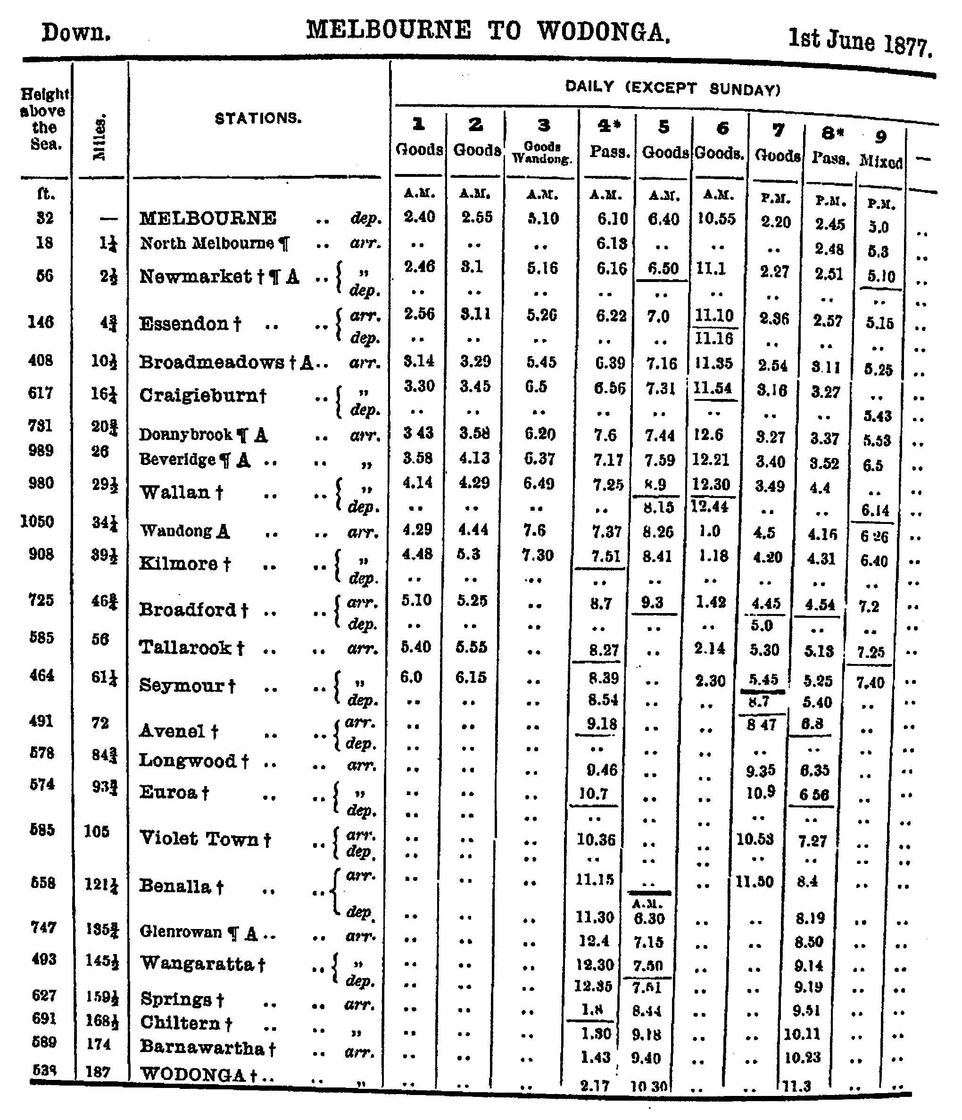

(Above) The timetable in force at the time of the accident. The two trains concerned are No 7 Goods and No 8 Pass. The timetable provided for No 7 Goods to wait at Broadford and be overtaken by No 8 Pass, but instead the SM there allowed the Goods to continue to run. One interesting aspect, only briefly alluded to in the newspaper reports, is that the running of the Pass had only recently been changed. Compared with the May 1877 timetable, the Pass left Melbourne exactly an hour earlier and had been slowed down by additional stops. It overtook the Goods at Seymour. In the July 1877 timetable, No 7 Goods had been rescheduled to depart 40 minutes earlier, and had time to reach Seymour before the Pass overtook it.

6. The goods train was despatched from Kilmore upon a staff ticket, and the passenger train upon the staff itself. Whilst the staff system provides against trains meeting face to face it does not provide against their overlapping if a sufficient interval is not allowed between their despatch from the same station in the same direction. In the case of the 2.20 p.m. goods train and the 2.15 p.m. passenger train, the general rule (rule 195, general rules and bye-laws) of 15 minutes interval is not observed, as shown in attached table. Nor was due regard given to the staff rules in issuing to the 2.20 p.m. goods train on 25th inst. of the staff ticket, which did not show the time of the train's departure from Kilmore. (This ticket we were unable to obtain, but we attach samples of similar tickets.)

7. Our attention was called to the want of a platform clock at Kilmore station, where there is only an office clock inside the station- master's office, which cannot be seen by enginemen and guards from the platform. On the morning of the accident, the guard (Barry) of the first down passenger train took the correct time along the line from Melbourne, and the evidence shows that although he gave the correct time to both the station- master and porter at Kilmore, the station-master did not, while the train was at the station, examine his office clock to see if it was correct.

8. We regret that the driver in charge of the passenger train did not check the time at Kilmore station, and he is to that extent amenable (sic).

9. We have not had an opportunity of taking the evidence of the guard (Cooney) of the passenger train; but we consider that we have sufficient evidence to come to a conclusion without him.

10. The engine driver of the passenger train, upon coming in sight of the goods train immediately reversed their (sic) engine and put steam against, and everything appears to have been done to lessen the force of the collision.

We have the honour to be, Sir,

Your most obedient servants,

S. MIRLS[1]

R. G. FORD[2]

W. B. FYFE[3]

ADDENDUM.

Since we concluded our report additional statements have been received from the assistant traffic manager, in report dated 3rd July, and the stationmaster at Kilmore in report dated 2nd July.

In relation to these statements, we have re-examined the guard, driver, and fireman of the 2.20 p.m. down goods train, and we also examined the running fireman of Melbourne (sic).

We find that driver Thompson stopped the train at about three quarters of a mile from the place of collision for less than one minute, to tighten up a pump gland. At the same time, he sent the fireman and guard to keep a look out. He considered that he was safe in stopping, being in advance of his time. After tightening up the gland he started his engine, and ran about three-quarters of a mile before the collision occurred. Neither the guard, driver nor fireman saw or heard the passenger train approaching.

The additional evidence does not alter the conclusion which we previously arrived at in fixing the time of the collision at 4.31 p., one minute before the passenger train should have left Kilmore; and this was the primary cause of the accident. Therefore, the time, 4 32 p.m., put down as the departure of the 2.45 p.m. down passenger train on the 25th inst. by the stationmaster, Kilmore, in his return of the arrival and departure of all trains at his station, is incorrect.

The board also furnished the following report on matters not bearing directly on the collision:

July 4, 1877.

1. In the course of the inquiry into the collision near Broadford, the attention of the board was called to a few matters not bearing directly upon the particular accident, but referring to the working of trains on the North-Eastern line.

2. Some of the trains run too close together. The morning goods train is sometimes overtaken by the second goods train, which leaves Melbourne only 15 minutes after it. The goods train in the afternoon precedes the passenger train at too short an interval. We consider that it would be better for the former to follow the latter.

3. We find in connexion with the staff system in operation upon this line that the regulations for working the trains are not rigidly adhered to, more especially in the issue and care of the staff tickets, as per samples attached, which were written out the day before they were used. There appears to be no printed staff tickets along the line, and the stationmasters having to make them from scrap paper, no actual time of departure from a station is given.

4. A large number of stations are without platform clocks, by which persons employed in working trains can verify the time. We consider a platform clock should be at all stations, duly regulated from Melbourne time.

5. The porters at Kilmore and Broadford work excessive hours-namely from half past 4 a.m. to half past 10 p.m. and occasionally till 2 a.m. We consider that such long hours of labour have a tendency to stupefy persons and to prevent the efficient execution of their duty from want of natural rest.

6. We find that the lamps of the advance[4] semaphores at Kilmore are not kept alight after the last train at night. We are of opinion that all advance semaphores at stations should have lights at night.

7. We also consider that every station upon a single line of railway should have telegraphic communication. At stations where nothing but train messages would be required a simple system such as Clark's or Tyre's (sic) should be adopted. The telegraph block system should be adopted between Broadmeadows and Essendon as trains frequently sight each other on Oliver's Bank[5].

During the course of the inquiry the Commissioner requested the traffic superintendent to furnish him with a list of all trains, passenger and goods, the one following the other on any single line at intervals of less than 30 minutes and the reason why; the system under which two trains can at the same time be on the line between any two stations, and travelling in the same direction, one only of which can carry the staff. A comparison of the smallness of the interval between following trains on single lines between the time-table now in force and the one the traffic superintendent proposed to put in force on the 1st of July. The times of the traffic on the block system and who is responsible for the present time-table. In response to this request the following memo was sent -

Traffic Manager's Office June 20

Memorandum for the Commissioner

In compliance with the Commissioner's instructions that I should furnish certain information as to the time-tables I beg to report as follows -

The only single line on which trains follow at less intervals than 30 minutes is the North Eastern. Nos 1 and 2 down start at an interval of 15 minutes and Nos 7 and down at an interval of 25 minutes which becomes reduced for the purpose of crossing to 15 minutes at Wallan, 11 minutes at Kilmore and nine minutes at Broadford where the trains pass. The times were originally fixed with reference to the convenience of certain hours for the goods traffic, the number of trains per diem, the places for shunting, the return of engines and general economy of working. Nos 7 and 8 trains have been without material alteration for over a year and the internal of time has been even less than it is now. Having regard to the gradients on the first section I have now altered some of the goods trains so as to keep an interval of 30 minutes. I attach a statement of the times of these trains for two years past, also copy of the staff regulations. Only the last train carries the staff. The train preceding it in the same direction carries a ticket. The traffic manager, and he solely, should be and is responsible for the time-table. He cannot devolve responsibility upon the engineering or locomotive branches, however he may have to consult them, either as to the state of the permanent way, the return of engines, rate of speed or load, &c. The block system is only in partial use on the Ballarat and main lines and it could not be materially extended without a great increase of telegraph stations and operators. There are several patents for signalling apparatus which can be worked by porters or unskilled persons, and there can be no doubt that if the adoption of Morse's system is considered too costly for general use one or other of these patents should be obtained to establish the complete block system on at least the first section of the North Eastern line – Anthony P Mathison.

The following is the minute of the Minster (John Woods) in referring the report of the board to the acting secretory -

This report, together with the evidence on which it is based, discloses irregularities in working and infringements of the published regulations of so serious a character as to call for explanations from the traffic manager.

According to the printed regulations 15 minutes must intervene between passenger and goods trains (see clause 195), and where there are two, the goods train must be shunted out of the way of the passenger train, which at that point must precede the goods train, the goods or slower train, not being allowed to start until five minutes after the passenger train has passed. The published time-table reduces the interval to nine minutes, and allows the goods or slower train to precede the passenger train. After so dangerous a violation of the printed regulations on the part of the traffic management, the loose and reckless manner in which business is conducted at the Kilmore station ceases to be a matter of surprise. This station seems to be practically in charge of a porter, who is required to be on duty at least 17 hours out of the 21 every day, and on some days more. He is allowed to start trains by a private and unreliable watch - passenger following goods trains at on interval of three minutes - and to relieve the stationmaster of the duty of handing at the proper time, and under stated conditions, the staff or staff ticket to the guard. (See Staff Regulations, clause 6 ). In the present case he (the porter) hands two staffs, not to the guard, but to the driver, and starts the passenger train after the goods by a watch which had lost 10 minutes during the night. The practice of writing staff tickets on loose slips of paper the day before they are wanted only serves to disclose the amount of recklessness and disorganisation which has been allowed to exist, no one knows to what extent or for how long. With so many facilities for trains to overlap, the only wonder is that so few collisions should occur.

The table of speeds necessary to be run in order to keep time (enclosed) illustrates the difficulty under which drivers are placed, varying as these speeds do, from 15 to 21 miles an hour. In his memo of the 25th ult., the assistant traffic manager places the time of collision at from 38 minutes past 4 to 40 minutes past 4. As the whole question of the responsibility pivots on the exact time when it took place, this becomes the most important feature in the inquiry. To my mind the board has demonstrated beyond the possibility of a doubt the fact that the collision took place at 31 minutes past 4 instead of at 38 minutes past 4 or 40 minutes past 4.

According to the published time-table, the train should have been standing still at Kilmore at the exact time when it was proved to have collided with the goods train, some six miles away; comment on this would be superfluous. The driver of the goods train stopped his engine three quarters of a mile from Broadford 'to tighten up the glands,' and although this circumstance in no way interferes with the fact that at the time be had a right to suppose the passenger train was six miles behind him still the necessity for stopping at all so near the station requires further explanation.

Suspend stationmaster at Kilmore, and relieve Porter Duffy, by giving him work at which he will not be required to be 17 out of the 21 hours on duty. Submit the names of all those suspended in connexion with the collision, to be farther dealt with. Ask explanations from the traffic and locomotive branches re the matters alluded to in this memo. The board has performed the task allotted to it in a searching and satisfactory manner

-JOHN WOODS.

## The Age, 1 August 1877 p2

The time of the hon. the Commissioner of Railways has been occupied to such an extent lately with deputations, the majority of which are absolutely useless, that he has not had an opportunity of thoroughly considering the important suggestions embodied in the report of the board appointed to inquire into the cause of the collision at Broadford, on the North-eastern line. He has arrived at no decision yet respecting the neglect of duty on the part of the station-master at Kilmore, who is still under suspension, nor has he dealt with the serious point laid against the traffic department, of not conforming to the rules and regulations of the Board of Land and Works relating to the time which must elapse before one train can follow another on a single line of railway. The cases of the drivers and stokers who wore suspended have been disposed of. The driver of the regular locomotive attached to the passenger train (Purves) was considered liable to some punishment for his carelessness in not observing the strict time of departure from Kilmore, and it has been ordered that his wages for the time he was under suspension should he forfeited, besides which he received a severe reprimand. Bowman, the driver of the assistant engine, was not considered legally responsible for the occurrence; and as he had submitted a somewhat reasonable excuse, he has been only lined to the extent of £1. Thompson, the driver of the goods train, has been fined £10 for stopping on the road to take up the glands of his engine, instead of driving into Broadford, so as to be under the protection of the semaphores. It is probable that the other matters referred to will be disposed of in the course of a week.

## Commentary

In 1877 the North East main line was single track north of Newmarket, and had been worked by Staff and Ticket since 1873. Indeed, it was the first line so equipped, which possibly explains the comments about the lack of printed Staff Tickets (the implication that other Staff & Tickets sections on other lines had this refinement). By June 1877 the staff sections south of Seymour were Essendon – Broadmeadows – Craigieburn – Wallan – Kilmore – Broadford – Tallarook – Seymour.

The Staff & Ticket System protected against opposing movements. Protection against following movements was by the standard time interval working used on double lines.

The accident is a classic time interval working accident. The goods train came to a stand in the section due to a mechanical failure and was run into by the following train. Note that the accident actually occurred after the goods train had restarted. This illustrates a major weakness of time interval working as practiced in Victoria (and the UK). When a train came to a stand in a section, the time interval was supposed to afford sufficient time for the guard to protect his train. However, nothing protected the train when the train started again and was slowly working up to speed. The US used fusees in this situation. A fusee was small pyrotechnic device. When lit, it burnt with a red light for five minutes, and then white for another five minutes. The rear end brakeman on a train travelling slowly would periodically light fusees and throw them onto the track. A following train, encountering a burning fusee would know that the preceding train had passed within five or ten minutes. Fusees were not used in either Australia or the UK, as far as I know. Perhaps they had not been invented in 1877.

The convoluted means of timing the accident illuminates another aspect of the 1870s Victorian Railways. Clearly none of the train crew of either train had an accurate watch. They were dependent on the station clocks for timekeeping. Equally clearly, the timekeeping on the stations was nearly as bad. Kilmore did not have a clock on the platform. Such clocks were a Board of Trade requirement in the UK, ostensibly for the passengers. But it is clear that in Victoria, at least, they were to be used by the train crews to regulate the running of their train. Time keeping at the stations was dependent on receiving the time from the guard of the first train (who had to have an accurate watch). With the clock in the station office, it is clear that the station staff at Kilmore did not have an easily accessible means of judging the time interval. Certainly, no sand glass or similar was provided.

Mathison’s comments about block working are also of interest. At the time of the accident, block working using the morse telegraph instruments was in use on the Warrenheip bank between Navigators – Warrenheip – Ballarat East. To introduce block working on the NE line would require telegraph instruments at all stations, together with qualified operators. Neither was available. But it is notable that by the Service Timetable of 10 October 1877 telegraph block was in use on the Down line between Wallan and Seymour. Mathison also highlights one of the advantages of the classic block instruments – they did not require operators qualified in Morse telegraphy.

The comments by the Board of Inquiry condemning the hours of duty of the porters at Kilmore and Broadford are of interest.

Finally, the comments by John Woods, the Minister of Railways, on the accident are of great interest. Woods considered that the Traffic Manager (and the senior management in the Traffic Branch) had also broken the regulations. The regulations required an interval of 15 minutes between a passenger and a goods train, but the timetable over-rode this regulation and allowed an interval of 9 minutes. The regulations also required a goods train to be shunted out of the way of a passenger train, but in this case the goods was deliberately timetabled in front of the passenger. The Traffic Manager’s excuse was that it was operationally convenient to ignore the regulations; essentially the same reason as many other more junior staff in later years.

There is interesting postscript to this story. Seven months after the accident the Berry government sacked a large number of senior public servants in an effort to pressure the Legislative Council into passing a bill authorising payment to Members of Parliament. Relatively few Railways Department employees were sacked on Black Wednesday, but Anthony Mathison was one of them.

# Bayswater

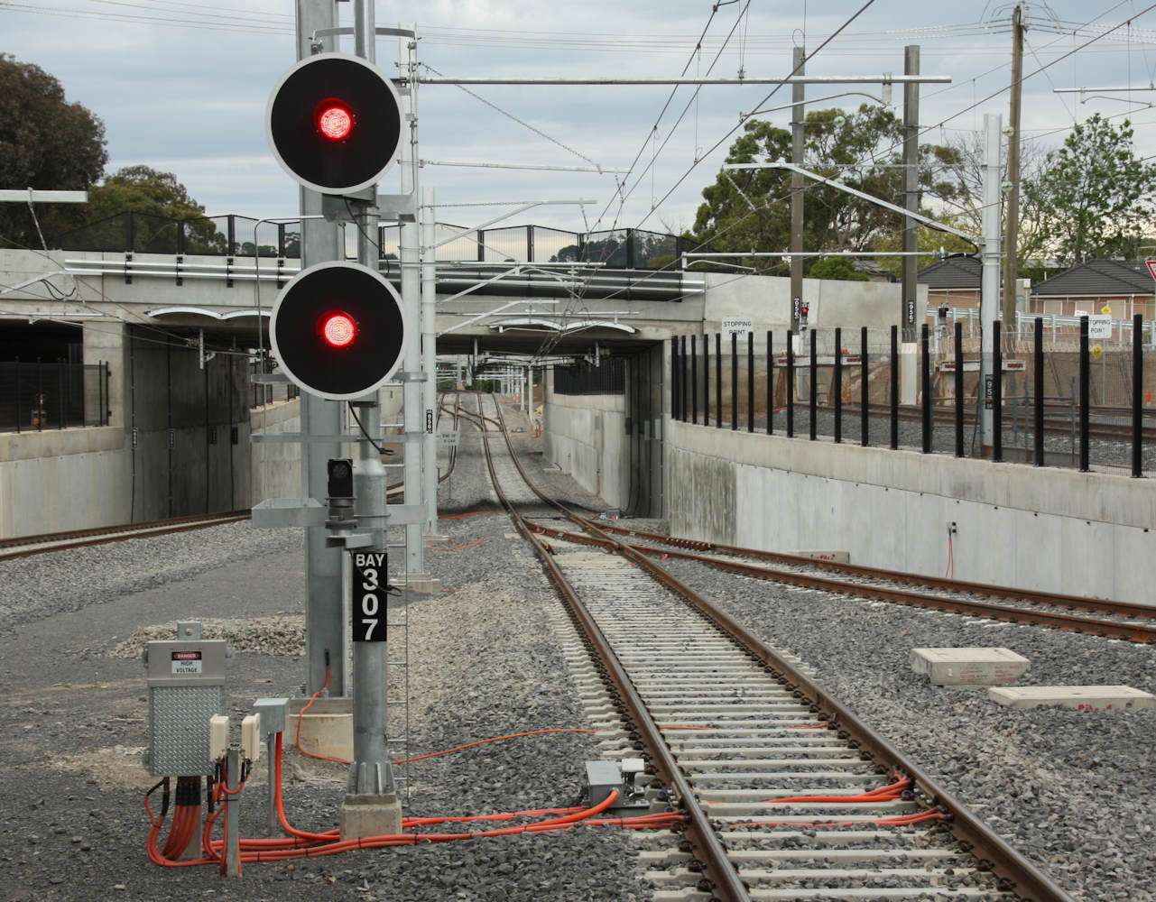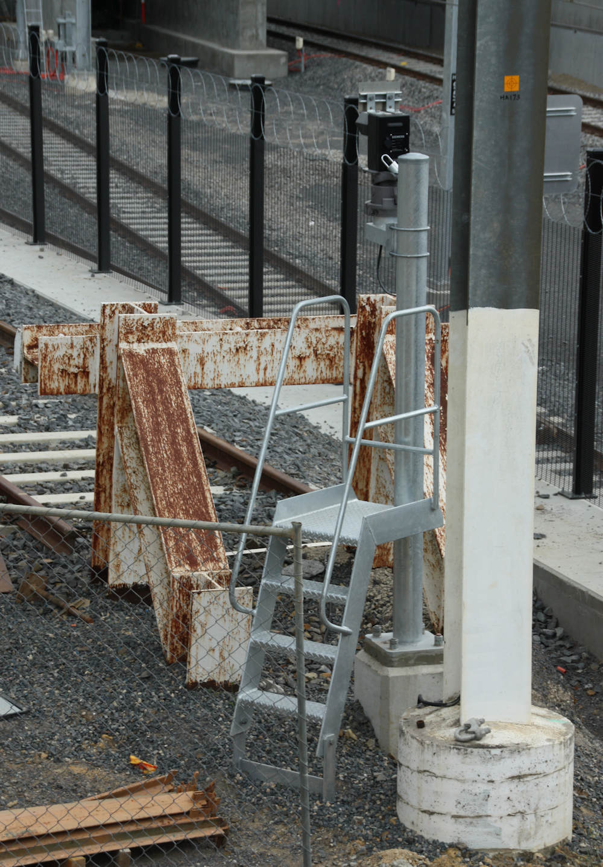

The new grade separated station at Bayswater was opened on 12 December 2016. These photos were taken in January 2017. (Above) Looking in the Up direction from the end of Platform 2 showing the new Mountain Highway overbridge. The design of the grade separation at Bayswater was constrained by the adjacent train maintenance facility. The lead to the train maintenance facility comes in from the right in this photo, and the need to ensure reasonable grades in this lead meant there was a limit to how far the track could be lowered. The solution was both lower the track and raise the road – the top of the retaining wall shows the original track level. One interesting feature at Bayswater was the provision of conventional signal masts where reasonable access existed to the mast, as in this case for BAY307. (Left) Dwarf BAY331 is fixed at stop and marks the buffer stops. Not all roads are provided with these fixed signals – No 3 & 4 South do not have them as they are the workshop, and No 6 Road does not have one as there is a windscreen repair shed at the end of that road.

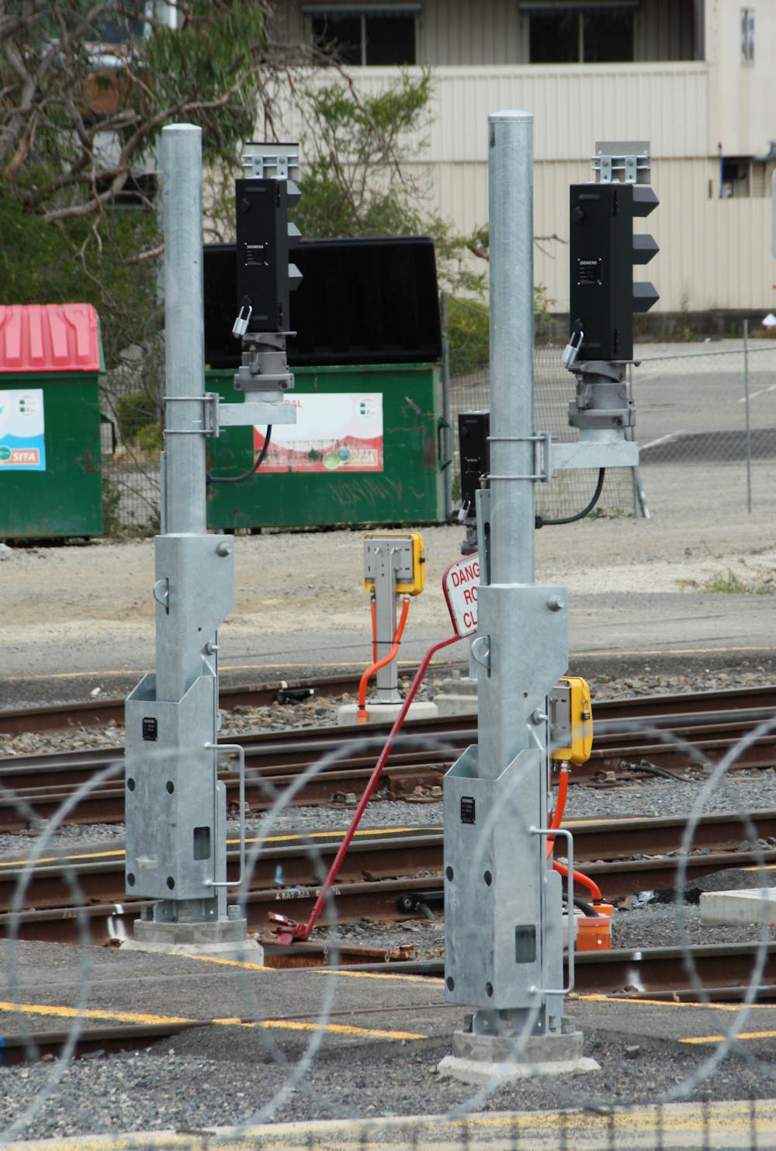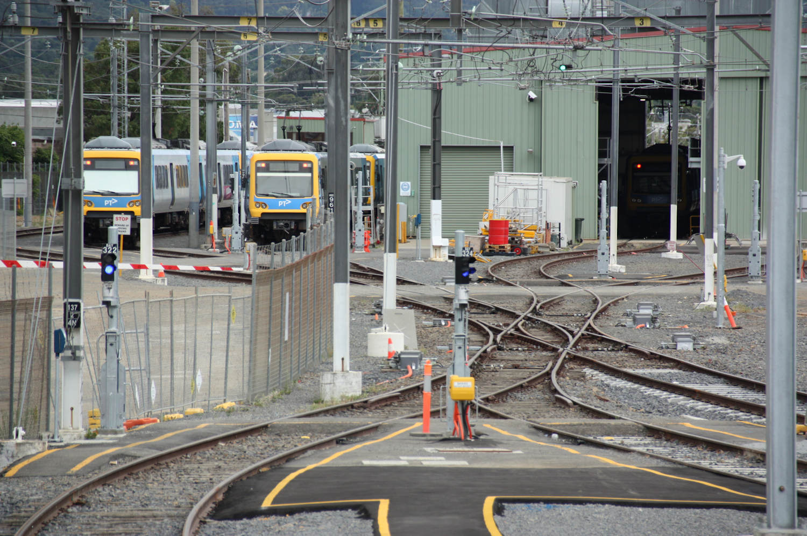(Above) A telephoto view of the length of the train maintenance facility, with Sidings No 3 North and No 4 North in the foreground. The signalling at Bayswater was renewed with the grade separation, and one change was the provision of full signalling in the Train Maintenance Facility. Formerly, movements in the depot area were controlled directly by the drivers using push button panels mounted at cab height. These could be used to call routes within the facility. The Signaller at Ringwood now works all points and signals within the facility, although the ‘Fleet Management Production Coordinator’ at Bayswater provides releases for moves to the sidings in the distance. (Right). The signals for moves within the Train Maintenance Facility are Dwarf signals mounted on tilt masts – these are the first location to have the Siemens type (developed for Auckland). It would appear that these are standard tilt bases with a short tubular mast. These dwarf masts have no counterweight, indeed the offset heads are intended to provide sufficient weight to allow the post to be lowered easily. The dwarfs can clearly display Clear Low Speed for moves onto the Up Main Line.

(Above) Road access to the train maintenance facility is controlled by this standard boom barrier, although note that no flashing lights or bell are provided. The boom is normally down. It can only be raised when the Signaller Ringwood give a release. Train movements in the sidings are detected using axle counters, and two of the termination boxes for the axle counter sections can be seen in the left foreground. 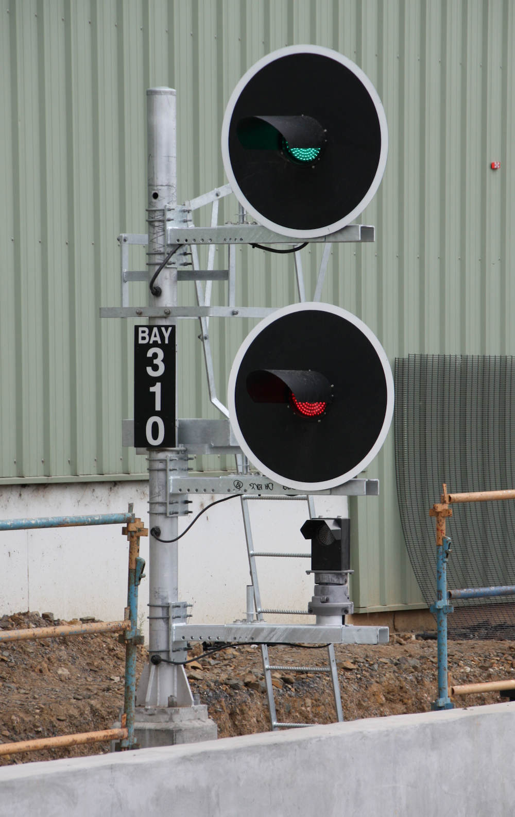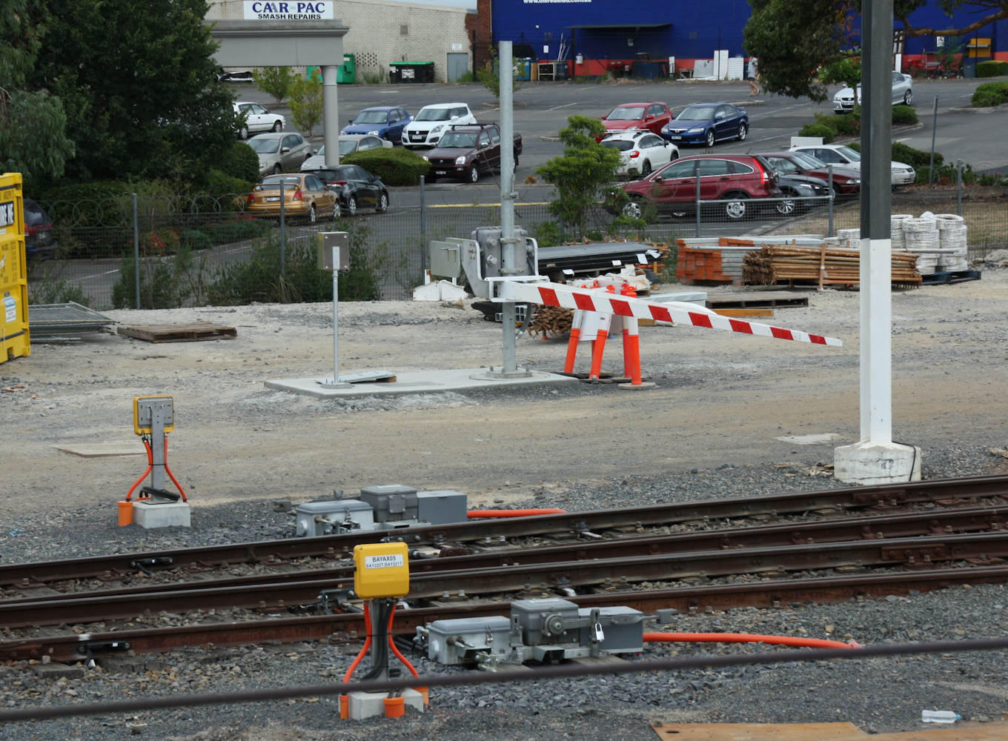(Right) Down Home BAY310 controls movements from Platform 2 to the Down line. There are no points in advance of this post, so its purpose is simple to allow the signaller to hold a train in Platform 2. The post structure is decidedly non-standard. A short mast is proved as the post is mounted on top of a low retaining wall. The three signal heads are mounted on light galvanised steel brackets – this is a benefit of modern signal heads. These have sheet steel cases and contain LED lights with plastic lenses. These are, of course, much lighter than the older cast iron cases, incandescent lamps, and glass lenses. The brackets slide to allow the signal maintainer to move the heads in for maintenance. This is the second use of such brackets in Victoria; the first is at South Kensington on the RRL.

1. Solomon Mirls, shortly to be appointed Locomotive Superintendent by the Railway Commissioner Woods
2. Robert Gray Ford, at this time an engineer in the Engineer-in-Chief’s branch and shortly to be made Engineer for Construction by Woods.
3. William Buist Fyfe. Subsequently became a District Traffic Superintendent.
4. Distant
5. Oliver’s Bank was the rising grade between the present day stations of Pascoe Vale and Glenroy. It is not known who Oliver was.